A picture containing clipart

Description generated with very high confidence

Hands-on

Adding a Member Account

AWS Solutions Architect

[**support@intellipaat.com**](mailto:support@intellipaat.com)

**+91-7022374614**

**US: 1-800-216-8930 (Toll Free)**

**Adding a Member Account**

**Step 1:** Launch an Amazon Linux 2 instance with a custom TCP rule of port 988 open

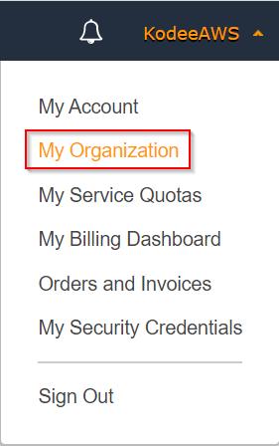

**Step 2:** Click on Add account

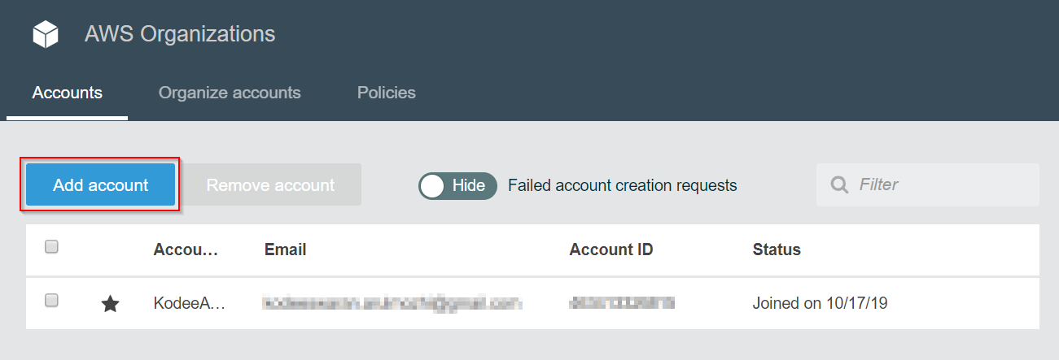

**Step 3:** Click on Create account. If you want to invite an existing AWS user, then click on Invite account

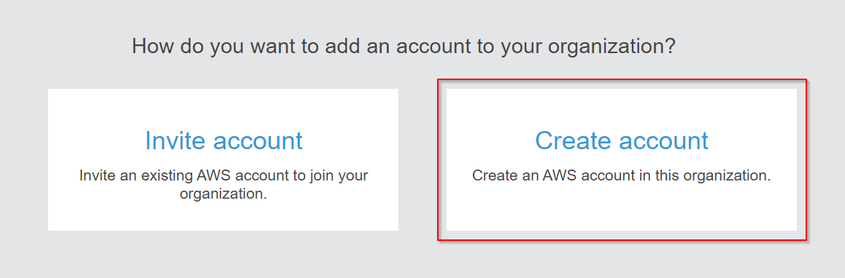

**Step 4:** Enter the details of the AWS account name and the email name which has to be contacted

